Bug Report - Buyer Actions > Release Items List (Filters and Sorting)
Module: Actions > Buyer Actions > Release | Build: Ultriva Lean Suite POC
Application URL | https://engineering.ultrivalms.com/POC/BuyerAction/ReleaseItems
User | buyeruser (Buyer K Test), Business Unit TCEK-Ram, Application (Plant), Supplier = Supnew (Supnew) for all filter/sort cases
Browser | Google Chrome (Selenium automation), 1920x1080
Execution date | 2026-10-10
Scope | Filters (Supplier, Cards, Show, Category, RYG), filter combinations, Search all columns, sorting of all 6 columns
Cases executed | 53 (Pass: 43, Fail: 7, System error: 2, Skipped: 1)
Bugs logged | 4

1. Bug Summary
Bug ID | Title | Area | Severity
BUG-REL-001 | System Error!! when Show = Cards List / My Cards List and Go is clicked | Filter - Show | High
BUG-REL-002 | RYG column cannot be sorted (header click has no effect) | Sorting | Medium
BUG-REL-003 | Description column sort order is inconsistent (e.g. 'ITSerial07222020_1' listed before 'IT_ERP_RECEIPTS') | Sorting | Medium
BUG-REL-004 | Text columns are sorted case-sensitively (lowercase values placed after uppercase values) | Sorting | Low

2. Bug Details

BUG-REL-001 - System Error!! when Show = Cards List / My Cards List and Go is clicked
Bug ID | BUG-REL-001
Summary | System Error!! when Show = Cards List / My Cards List and Go is clicked
Module | Actions > Buyer Actions > Release > Release Items List
Environment | https://engineering.ultrivalms.com/POC, Chrome, user buyeruser
Severity | High
Priority | P1
Related test cases | TC_020, TC_022
Steps to reproduce | 1. Log in as buyeruser / Ultriva!23.  2. Click Actions > Buyer Actions > Release (Release Items List).  3. Open Release Items List, set Show = 'Cards List' (or 'My Cards List') and click Go.
Expected result | Release Cards List opens with the cards of the selected filters.
Actual result | Page /BuyerAction/ReleaseCards shows 'Sorry, an error occurred while processing your request. System Error!!' (reproduced twice per case).
Status | Open
Screenshot | 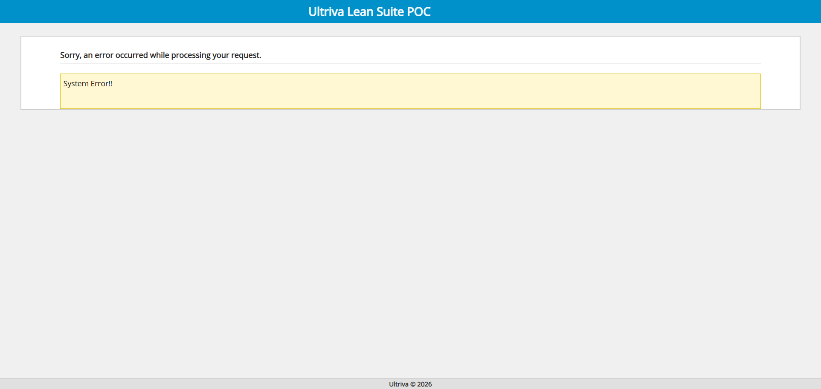

BUG-REL-002 - RYG column cannot be sorted (header click has no effect)
Bug ID | BUG-REL-002
Summary | RYG column cannot be sorted (header click has no effect)
Module | Actions > Buyer Actions > Release > Release Items List
Environment | https://engineering.ultrivalms.com/POC, Chrome, user buyeruser
Severity | Medium
Priority | P2
Related test cases | TC_305
Steps to reproduce | 1. Log in as buyeruser / Ultriva!23.  2. Click Actions > Buyer Actions > Release (Release Items List).  3. Click the 'RYG' column header once, twice and a third time.
Expected result | Rows are ordered by RYG status (ascending / descending), as for the other columns.
Actual result | asc: WRONG (colour groups in order: ['SQ0.gif', 'SQ2.gif', 'SQ0.gif', 'SQ2.gif', 'SQ0.gif'] | aria-sort='None' expected ascending) || desc: WRONG (colour groups in order: ['SQ0.gif', 'SQ2.gif', 'SQ0.gif', 'SQ2.gif', 'SQ0.gif'] | aria-sort='None' expected descending) || 3rd click state=None, original order restored=True
Status | Open
Screenshot | 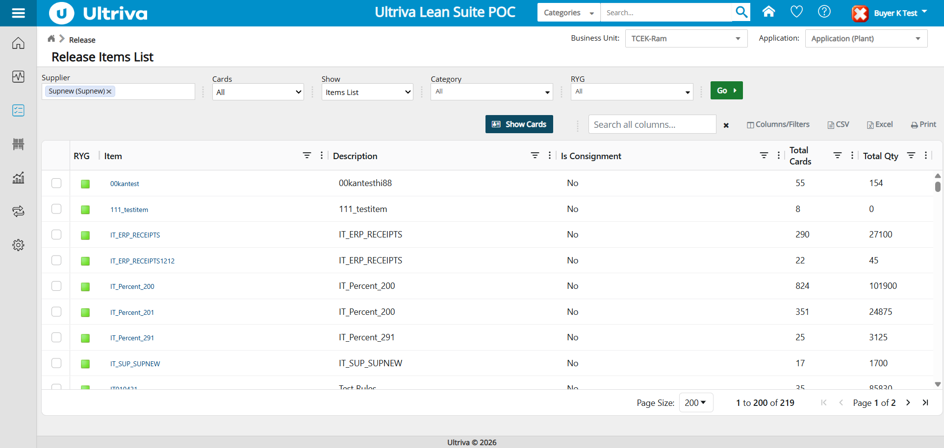

BUG-REL-003 - Description column sort order is inconsistent (e.g. 'ITSerial07222020_1' listed before 'IT_ERP_RECEIPTS')
Bug ID | BUG-REL-003
Summary | Description column sort order is inconsistent (e.g. 'ITSerial07222020_1' listed before 'IT_ERP_RECEIPTS')
Module | Actions > Buyer Actions > Release > Release Items List
Environment | https://engineering.ultrivalms.com/POC, Chrome, user buyeruser
Severity | Medium
Priority | P2
Related test cases | TC_307
Steps to reproduce | 1. Log in as buyeruser / Ultriva!23.  2. Click Actions > Buyer Actions > Release (Release Items List).  3. Click the 'Description' column header (ascending) and compare neighbouring values around row 22.
Expected result | Consistent alphabetical order (case-insensitive) for the whole list.
Actual result | asc: WRONG (not in ascending order; first violation: row 22 'ITSerial07222020_1' before row 23 'IT_ERP_RECEIPTS'; first ['!@#$%%%', '00kantesthi88', '10 regression', '10 version regression testing']) || desc: WRONG (not in descending order; first violation: row 9 'test' before row 10 'Testcheckboxes'; first ['test test', 'test QMS module', 'test Netted calculations', 'test']) || 3rd click state=none, original order restored=True
Status | Open
Screenshot

BUG-REL-004 - Text columns are sorted case-sensitively (lowercase values placed after uppercase values)
Bug ID | BUG-REL-004
Summary | Text columns are sorted case-sensitively (lowercase values placed after uppercase values)
Module | Actions > Buyer Actions > Release > Release Items List
Environment | https://engineering.ultrivalms.com/POC, Chrome, user buyeruser
Severity | Low
Priority | P3
Related test cases | TC_306, TC_312
Steps to reproduce | 1. Log in as buyeruser / Ultriva!23.  2. Click Actions > Buyer Actions > Release (Release Items List).  3. Click the 'Item' or 'Description' column header (ascending / descending) and view the order.
Expected result | Case-insensitive alphabetical order.
Actual result | Sort column 'Item' asc / desc / clear: asc: WRONG (first ['00kantest', '111_testitem', 'IT010421', 'IT010724', 'IT010822']; order is case-sensitive (lowercase values after uppercase) | order is case-sensitive (lowercase after uppercase)) || desc: WRONG (first || Sort a filtered result (Green + Kanban) by Item: Filtered (176 rows) + sorted by Item asc: first ['00kantest', '111_testitem', 'IT010421', 'IT010724', 'IT010822']; order is case-sensitive (lowercase values after uppercase)
Status | Open
Screenshot

3. Cases Skipped (System / Automation Error)
Case ID | Title | Error
TC_020 | Show = Cards List | System Error!! page displayed (URL: https://engineering.ultrivalms.com/POC/BuyerAction/ReleaseCards)
TC_022 | Show = My Cards List | System Error!! page displayed (URL: https://engineering.ultrivalms.com/POC/BuyerAction/ReleaseCards)
TC_303 | Multiple suppliers (Supnew + Sup111023) | Automation error, case skipped: Supplier suggestion 'Sup111023 (Sup111023)' not found in []

4. Execution Notes
Filters were verified against the unfiltered Supnew list (219 rows): RYG colour indicators, Category, Cards aging and Show against the single-filter results, and every combination against each of its single filters. Each column was sorted ascending, descending and cleared, and the order was checked across both pages. Cases that hit a system error were retried once, logged, and the run continued with the next case. Cases where the data set has no matching rows (for example no Yellow items) are not logged as bugs.

